You are given an m x n integer matrix grid​​​.

A **rhombus sum** is the sum of the elements that form **the** **border** of a regular rhombus shape in grid​​​. The rhombus must have the shape of a square rotated 45 degrees with each of the corners centered in a grid cell. Below is an image of four valid rhombus shapes with the corresponding colored cells that should be included in each **rhombus sum**:

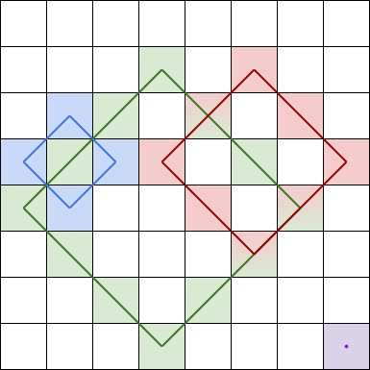

Note that the rhombus can have an area of 0, which is depicted by the purple rhombus in the bottom right corner.

Return *the biggest three****distinct rhombus sums****in the*grid*in****descending order****. If there are less than three distinct values, return all of them*.

**Example 1:**

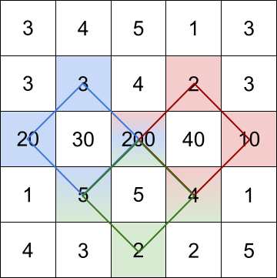

**Input:** grid = [[3,4,5,1,3],[3,3,4,2,3],[20,30,200,40,10],[1,5,5,4,1],[4,3,2,2,5]]

**Output:** [228,216,211]

**Explanation:** The rhombus shapes for the three biggest distinct rhombus sums are depicted above.

- Blue: 20 + 3 + 200 + 5 = 228

- Red: 200 + 2 + 10 + 4 = 216

- Green: 5 + 200 + 4 + 2 = 211

**Example 2:**

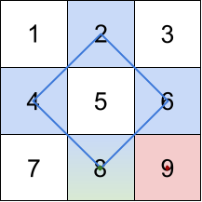

**Input:** grid = [[1,2,3],[4,5,6],[7,8,9]]

**Output:** [20,9,8]

**Explanation:** The rhombus shapes for the three biggest distinct rhombus sums are depicted above.

- Blue: 4 + 2 + 6 + 8 = 20

- Red: 9 (area 0 rhombus in the bottom right corner)

- Green: 8 (area 0 rhombus in the bottom middle)

**Example 3:**

**Input:** grid = [[7,7,7]]

**Output:** [7]

**Explanation:** All three possible rhombus sums are the same, so return [7].

**Constraints:**

* m == grid.length
* n == grid[i].length
* 1 <= m, n <= 50
* 1 <= grid[i][j] <= 105